MEMORY GO ROUND
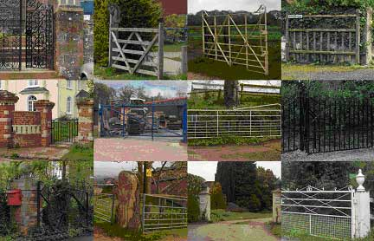

The correct order was as follows:

11  Whimple Church | 5 | 1  Field gate at Hitts Barton | 9
12 | 6 | 3 | 10
2  New Hayes – house on R | 7 | 8 | 4

Tie Breaker
10
This was the number of times the route crossed the railway line, either under or over.

