



2006
INFORMATION:
START: Newton Abbot Rec. Trust, Marsh road, Newton Abbot. GR:864716
Start from 9.30am, we intend to start most between 9.30 and 10.00, in small groups.

ROUTE: The first loop is about 38Km with about 12Km off road on tracks and bridleways. Two quite long climbs mainly on road, but one very steep rocky climb near Lustleigh for about 500m.
The second loop has some less severe climbs, but plenty of them, and takes you though some quite muddy lanes. About 22Km with 9Km of tracks and bridlepaths.

TIME: There is no set time limit but to save our helpers at checkpoints having to be there all day, we estimate that the first loop should take between 2.5 and 4.5 hours, and the last loop between 1.5 and 3 hours, so we hope you will all be back to the finish before 17.30 Please note that the event is NOT a race.

FOOD: The Recreational Trust will be helping us out by allowing use of their facilities at Newton Abbot. There will be teas and coffees and sandwiches and cakes available for purchase, when you arrive here after the first leg, and teas and coffees at the finish. Note that there will be a cricket match on that afternoon, so the area will be fairly busy.

MAPS: The route sheet is comprehensive, but we would recommend that you use the Ordnance Survey Explorer 31(Torbay), and Explorer OL28 (Dartmoor)maps in conjunction with it for good detail. ( Route sheet available at start and on website)

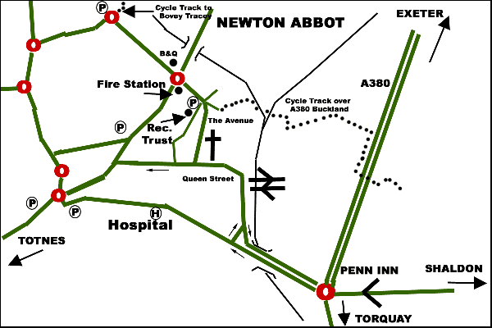
    ww.ctcdevon.co.uk www.mooraccord.org.uk    


