SATURDAY 1ST DECEMBER 2007

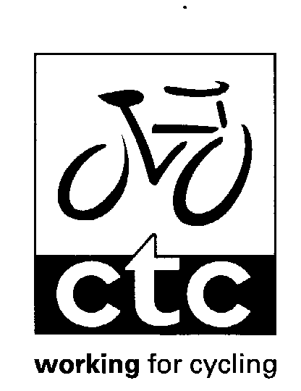
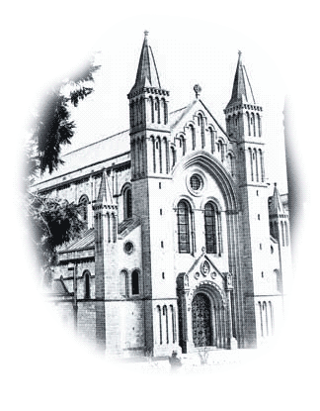
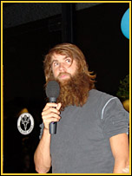
Ed Genochio

This year’s Annual Dinner & prize giving is being held at the Grange Restaurant at Buckfast Abbey commencing at 6:30pm until 11:00pm.

We welcome back last year’s special guest Ed Genochio (without his beard) to conclude his globetrotting trip to China. Last year we heard about the outward expedition. This year we will hear about his return accompanied by slides.

There will be another collection of bikes on display from John Dodson.

Christmas Menu:
Soup or Fruit Juice
--------------------
Roast Turkey with Stuffing, Cranberry Sauce & Chipolatas
Or
Roast Beef & Yorkshire Pudding
Or
Vegetarian Option of Nut Roast
All served with Roast Potatoes & Fresh Vegetables
------------------
Christmas Pudding
-----------------
Mince Pies with Clotted Cream
----------------
Coffee & Petit Fours
The meal will commence at 7:00 prompt to ensure we complete the proceedings well before the closing time to give time to look at the bikes and to socialise.

Ticket price £17:50

Please return the form below with your name & meal choice and send it to Bill Barnes, with cheques payable to CTC Devon DA, at 70 Cleeve Drive, Ivybridge PL21 9BP

TICKET PRICE £17.50

MONEY & MEAL CHOICE WITH ORDER TO BILL BARNES. 70 CLEEVE DRIVE, IVYBRIDGE PL21 9BP
CHEQUES PAYABLE TO CTC DEVON DA


NAME:
----------------------------------------------------------------------------------------------------------------------------

MEAL (CIRCLE CHOICE): SOUP FRUIT JUICE

TURKEY BEEF NUT ROAST

